**INDIVIDUAL ANALYSIS REPORT**

Group C1.04.05

07/03/2023

Author(s):

Carlos Bermejo Soria,[*carbersor@alum.us.es*](mailto:carbersor@alum.us.es)

**Table of contents**

**Table of contents** **2**

**1. Executive summary** **3**

**2. Revision table** **3**

**3. Introduction** **3**

**4. Contents** **3**

4.1. Performed tasks 3

4.2. Budget 4

**5. Conclusions** **4**

**6. Bibliography** **4**

1. **Executive summary**

This report summarizes the analysis needed for the second deliverable for Carlos Bermejo Soria’s work.

1. **Revision table**

| **No** | **Date** | **Description** |
| --- | --- | --- |
| 1.0 | 30/04/2023 | Initial draft of the document. |
| 1.1 | 26/05/2023 | Final revision. |

1. **Introduction**

The analysis of the requirements is fundamental in every project to get the necessities of the customer right and understand the domain with precision. The documents provided to us already give a detailed expression of what the requirements might be and what they need to be completely fulfilled. If any of those requirements implores extra analysis it will be documented on these analysis reports throughout the different deliverables of the project.

1. **Contents**

This delivery required some analysis for the correct understanding of the requirements. Each of these decisions were taken having in mind the comments in the forum and the teacher’s advice.

**4.1. Requirements**

* **RI 19.** Most of the tutorials’ negative tests were considered unnecessary due to the already tested features in the positive tests.
* **RI 20.** Most of the tutorial sessions’ negative tests were considered unnecessary due to the already tested features in the positive tests.

**4.2. Diagrams**

For this set of requirements I decided to make an individual UML model to represent each of the entities and classes needed for the deliverable, including their attributes, relations and restrictions.

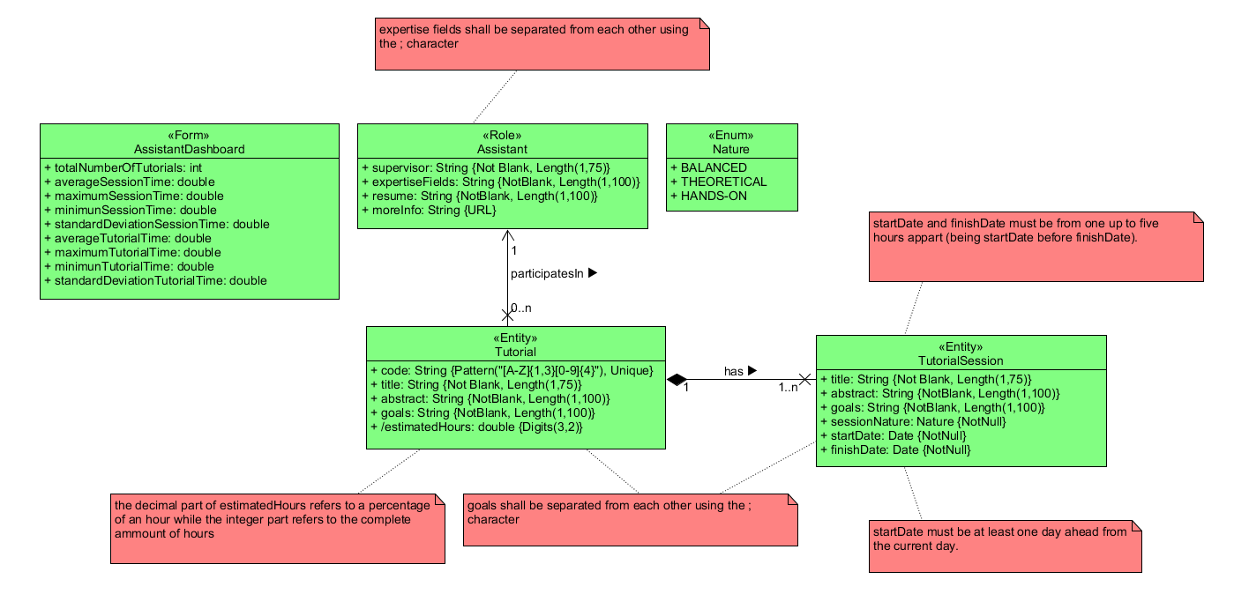

1. **Conclusions**

These were the overall details of the performed individual task by the member Carlos Bermejo Soria.

1. **Bibliography**

<Intentionally blank>